Dashboard Design

Date | 18-09-2026
Team ID | MCA
Project Name | Smartphone Usage, Digital Addiction & Well-Being Analytics
Maximum Marks | 5 Marks

Creating an effective dashboard involves thoughtful design to ensure that the presented information is clear, relevant, and easily understandable for the intended audience. Here are some key principles and best practices for dashboard design.
Activity 1: Interactive and visually appealing dashboards
Creating interactive and visually appealing dashboards involves a combination of thoughtful design, effective use of visual elements, and the incorporation of interactive features. Here are some tips to help you design dashboards that are both visually appealing and engaging for users, keeping in mind the key points from the dashboard layout:

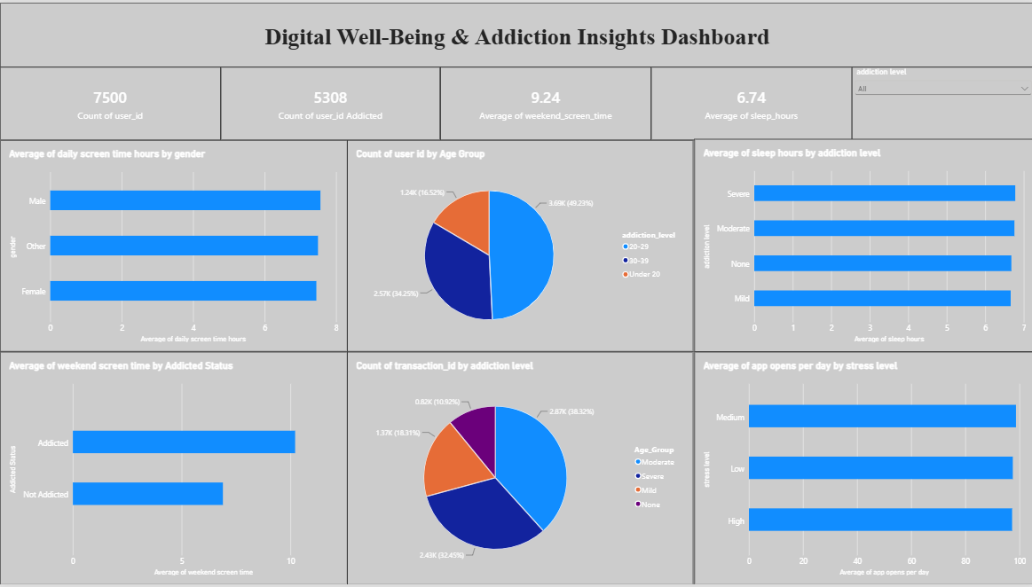

- Total Monitored Cohort: The system tracks metrics across a total volume of 7,500 user IDs, establishing the baseline population for the insights.
- Prevalence of Addiction: Out of the monitored population, 5,308 users are classified under the "Addicted" status, indicating a prominent area of concern for digital well-being.
- Extensive Weekend Screentime: The cohort exhibits a high dependency during days off, spending an average weekend screen time of 9.24 hours on their devices.
- Sleep Patterns: Across various addiction segments, users manage an average sleep duration of 6.74 hours, highlighting the biological footprint of high device usage.
- Age Group Demographics: The breakdown reveals that the largest segment under observation belongs to the 20–29 age bracket (3,425 users), followed by the 30–39 group (2,570 users), making young adults the primary demographic of this study.
- Gender Screentime Comparison: Daily device utilization is closely shared across demographics, with male users averaging slightly over 7.5 hours, mirrored nearly equally by female and other gender categories.
- Weekend Impact Analysis: Users explicitly designated as "Addicted" see their average weekend screen time climb to approximately 10 hours, demonstrating a stark increase compared to non-addicted users who stay closer to 6 hours.
- App Engagement & Stress: App activation frequencies are mapped alongside user mental state indicators, showing high transaction counts among those experiencing moderate-to-severe addiction levels.

